Chapter 14, Problem 96.

The crossover circuit in Fig. 14.108 is a lowpass filter that is connected to a woofer. Find the transfer function H(ω) = V_{o}(ω)/V_{i}(ω).

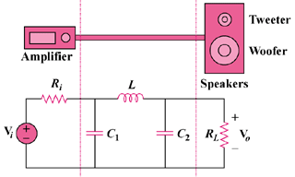

Figure 14.108
For Prob. 14.96.

